October 11, 2024

TO: Advisory Committee on Plants and Animals

FROM: Povi Carisa-Abney

Wildlife Supervisor

Hyatt Regency Maui Resort and Spa

200 Nohea Kai Drive

Lahaina, Hawaii 96761

THROUGH: Jessica Ann Miura

Acting Land Vertebrate Specialist

Plant Quarantine Branch

SUBJECT: Request to: (1) Allow the Importation of Four (4) African Black-Footed Penguins, *Spheniscus demersus,* an Animal on the List of Restricted Animals (Part B), by Permit, for Exhibition, by Hyatt Regency Maui Resort and Spa; and (2) Update Permit Conditions for the Importation and Possession of Four (4) African Black-Footed Penguins, *Spheniscus demersus,* an Animal on the List of Restricted Animals (Part B), for Exhibition, by Hyatt Regency Maui Resort and Spa.

**I. Summary Description of the Request**

***PQB NOTES:*** *The Plant Quarantine Branch (PQB) submittal for requests to import or permits to possess, as revised, distinguishes information provided by the applicant from procedural information, advisory, and evaluative comments presented by PQB. Except for PQB notes, hereafter “PQB NOTES,” the information provided in Section II from page 2 through page 9 of this submittal is taken directly from the Hyatt Regency Maui Resort and Spa’s application and subsequent written communications provided by the applicant Mrs. Povi Carisa-Abney. For instance, the statements on page 7 regarding effects on the environment are the applicant’s statements in response to standard PQB questions and are not PQB’s statements. This approach promotes greater applicant participation in presenting import requests in order to expeditiously move these requests to the Board of Agriculture (Board), while also distinguishing applicant provided information from PQB information. The portion of the submittal prepared by PQB, including the Proposed Import Conditions and Advisory Subcommittee Review, is identified as Sections III and IV of the submittal, which begins on pages 9 and 12, respectively.*

We have a request to review the following:

**COMMODITY:** Four (4) African Black-Footed Penguins, *Spheniscus demersus*

(Refer to Appendix A for Permit Application).

**SHIPPERS:**  Metro Richmond Zoo,

8300 Beaver Bridge Road

Moseley, VA 23120

Phone No.: [(804) 739-5666](https://www.google.com/search?q=international+animal+exchange&rlz=1C1CHBF_enUS879US879&oq=international+animal+ex&aqs=chrome.0.0i355i512j46i175i199i512j69i57j0i512j0i22i30i457j0i22i30l5.4117j0j15&sourceid=chrome&ie=UTF-8).

**IMPORTER:** Povi Carisa-Abney, Wildlife Supervisor

Hyatt Regency Maui Resort and Spa

200 Nohea Kai Drive

Lahaina, Hawaii 96761.

Phone No.: (808) 250-1030. Fax No.: (808) 667-4717.

(Refer to Appendix B for resume).

***PQB NOTES:*** *The PQB has previously approved import permits for Patricia Lonick, Hyatt Regency-Maui, on November 10, 1992 and December 1, 1992 to import Black-Footed Penguins, Spheniscus demersus and Magellanic Penguins, Spheniscus magellanicus. (Refer to Attachment 1 and 2).*

**CATEGORY:** African Black-Footed Penguins, *Spheniscus demersus,* are on the List of Restricted Animals (Part B). Pursuant to Hawaii Administrative Rules (HAR), Chapter 4-71, all species in the family Spheniscidae may be imported into Hawaii for government use, or private and commercial use, including research, zoological parks, or aquaculture production.

**II. Information Provided by the Applicant in Support of the Application**

**PROJECT:** Currently, our facility can no longer produce viable offspring as they are too closely related. We are seeking to obtain 4 penguins of a different bloodline to ensure genetic vitality. We have recently been accepted into Zoological Association of America’s (ZAA) Animal Management Program for African Penguins (Refer to Attachment 3 for ZAA Memorandum of Participation) and obtained a Captive-Bred Wildlife Permit through US Fish and Wildlife (MAPER3778561) (Refer to Attachment 4 for U.S. Fish and Wildlife Captive-bred Wildlife Registration Permit). We have also registered our penguins to the Association of Zoos and Aquariums (AZA) Regional Studbook and they have determined our penguin population is genetically unique. These collective histories, compiled and maintained by an AZA Regional Studbook Keeper, are known as the population's genetic and demographic identity and are valuable tools to track and manage each individual as part of a single *ex situ* population. (Refer to Attachment 5 for the AZA Species Survival Plan Program Handbook).

**OBJECTIVE:** We are also seeking to obtain 4 new penguins in order to comply with AZA’s minimum population standard recommendation of 10 penguins for animal enclosure of our size. (Refer to Attachment 6 for the AZA Penguin (Spheniscidae) Care Manual). With the introduction of a new bloodline, it is our hope that our penguins will produce healthy offspring to continue the future of our colony. If we enter a situation of having surplus penguins, we contact ZAA’s Animal Management Plant to see if there is a need at other facilities for African Penguins, and follow all recommendations, rules and regulations regarding this species. Additionally, the penguins will be used for exhibition at the Hyatt Regency Maui Resort and Spa.

**PROCEDURE:** Our penguin habitat was designed to house 12-16 penguins and we now only have 5 penguins. Should we have surplus penguins, our habitat can be restructured to house up to 20 penguins. We have had a very successful colony of penguins at the Hyatt Regency Maui for 38 years. Our 3 “founding” penguins all lived past their expected lifespan and have produced 6 healthy offspring.

**DISCUSSION:**

**1. Person Responsible:** Povi Carisa-Abney

Wildlife Supervisor, Hyatt Regency Maui

200 Nohea Drive

Lahaina, Hawaii 96761.

Phone No.: (808) 250-1030.

Email Address: povi.carisa-abney@hyatt.com

I am the wildlife supervisor at the Hyatt Regency Maui and have worked with animals for over 30 years, caring for these penguins over the last 5 years. I will use my experience with these animals and other experts in the field to provide these penguins with the best care possible. I am an active member of AZA and have connections at several zoos and aquariums that work with African penguins. I work with a very skilled team of wildlife technicians, and an exotic animal’s veterinarian who provide amazing care to our penguins. They include:

Lisa Braun, 3.5 years with African Penguins, 12 years animal experience

Julia Chambers, 2 years with African Penguins, 10 years animal experience

(Refer to Attachment 7 for Julia Chamber’s resume).

Allison Strassburg, 1 year with African Penguins, 8 years animal experience

(Refer to Attachment 8 for Allison Strassburg’s resume).

Dr. Paul McCurty: Veterinarian (contracted). 16 years wildlife medicine/12 years as a vet

**2. Safeguard Facility and Practices:**

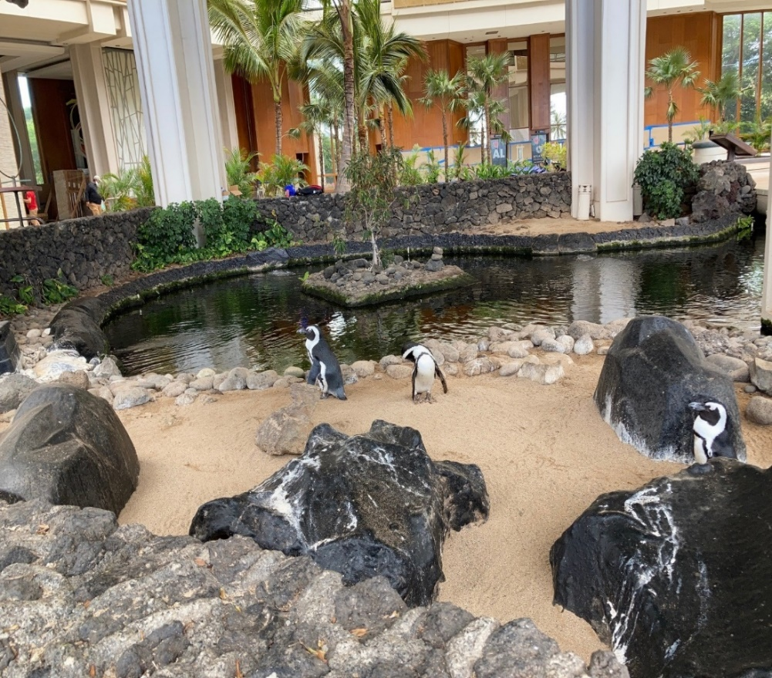Our penguin habitat (Refer to Attachment 9 for aerial map of facility) is inside the Hyatt Regency Resort Maui at 200 Nohea Drive, Lahaina, HI 96761. I have provided a photo and a map of our penguin enclosure below. This habitat is safeguarded by a lava rock wall to keep penguins inside and to protect from the elements. We have 24-hour security on property, and water features that monitor the penguins’ water quality. We also have a quarantine space inside for severe weather, training, and minor medical procedures. Care for major illness/injuries would take place at South Maui Animal Clinic in Kihei, Maui. We follow AZA guidelines for penguin welfare and the Hawaii Department of Agriculture (HDOA) provides yearly inspections. (Refer to Attachment 6 for the AZA Penguin (Spheniscidae) Care Manual).

Figure 1. Photograph of Penguin Enclosure

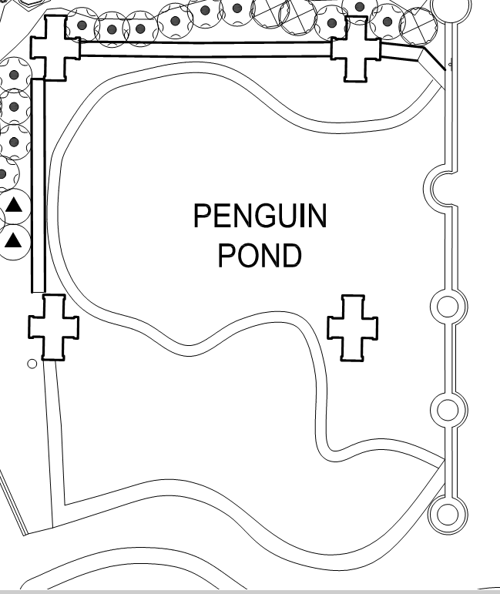Our penguin habitat is located in the center of our main lobby. It is made up of a sand beach and walkway, a rock beach, hard plastic igloo-style penguin houses, and a waterway with a plastic liner. We have plants growing in all the corners and trees that provide shade. The habitat is kept enclosed by a lava-rock wall and concrete bridge (Refer to Attachment 10 for additional photographs). We have 3 occupied houses, 3 empty houses with space for at least 2 more homes, and each igloo typically houses 2 penguins.

Figure 2. Diagram of the Penguin Enclosure. Dimensions are approximately 37’ x 44’ or 1,624 sq. ft. total enclosure area.

**3.** **Method of Disposition:** We are looking to acquire penguins to keep our colony going for generations to come. We have no plans to end this project, but should our penguins have to be re-homed, we would contact ZAA’s African Penguin Animal Management Plant to find a suitable home for them. When a penguin dies, we send the body in for a necropsy to better understand the cause of death, then would dispose of the body through cremation.

We keep our penguins enclosed and they are monitored through our 24-hour security team and multiple security cameras on property. This is not a species that could establish a wild colony in Hawaii due to lack of food (they eat cold-water schooling fish not found in Hawaii).

**4. Abstract of Organisms:**

1. **African Black-Footed Penguin also known as Jackass Penguin and African Penguin** *(Spheniscus demersus).*
2. They have no close relatives in Hawaii.
3. The African penguin averages 2 ft. tall and weighs up to 8 lbs. Eggs are laid in pairs and both parents help incubate and feed offspring. After 2-4 years, the chicks will mature and lay their own eggs. Reproductively mature at 4-6, they typically live 10-15 years in the wild but longer in captivity. They tolerate extreme temperatures of 40-100 degrees, regulate heat well, and do well in our moderate climate.
4. Their habitats require shelter, a dry substrate like sand, rock beaches, water and shade.
5. Native range is South Africa.
6. This is not a species that could establish a wild colony in Hawaii due to lack of this species food (they eat cold-water schooling fish not found in Hawaii).
7. African Penguins have not established a viable population anywhere except Africa.
8. African Penguins feed on cold water schooling fish like sardines, anchovies and capelin (not found in Hawaii). This species is not considered a pest or invasive as it does not inhabit anywhere except Africa.
9. This species is not considered domesticated, nor is it cultivated for commercial purposes.
10. This species is declining in its natural environment, mainly due to overfishing, loss of habitat, global warming and human impact.
11. Illnesses and bacteria: salmonellosis, clostridiums, and the polymicrobial contribution to penguin diphtheria, avian malaria and aspergillosis.
12. Not a threat to local wildlife through disease or parasites as they are in an enclosed area and contained water system.

We have had a very successful colony of penguins at the Hyatt Regency Maui for 40 years. Our 3 “founding” penguins all lived past their expected lifespan and have produced 6 healthy offspring. We have come to a point where our penguins are too closely related to produce offspring of genetic vitality, and our current penguins will begin to age out of their healthiest reproductive years. Our enclosure can support the additional penguins and we feel it is important to contribute to this population of endangered species. We have an excellent support team, connections with several other zoos and aquariums, an active role in the AZA, ZAA, a strong working relationship with our veterinarian, as well as the Department of Agriculture’s Quarantine department. It is our goal to provide all of our penguins with the best care and welfare possible, and to work with USDA, ZAA and US Fish and Wildlife to help revive a declining species.

The last of our original penguins passed away on March 1, 2021 at the age of 36, and the other two lived to 25 and 27. We are currently housing their 4 offspring.

* Number of years we have had African Penguins: 40
* Successful births in the last 5 years: 0
* Mortalities in the last 5 years: 2
  + “Oreo”, the last original penguin, passed due to cancer/advanced age- 36 years old.
  + “Mai”, passed on January 26, 2024, due to a ruptured ovarian follicle- 14 years old.

We will continue to give all our penguins the best nutrition, habitat, medical care, enrichment, social opportunities and overall welfare to ensure our penguins live long, healthy lives.

**5. Effects on the Environment:** There should be very little environmental impact regarding our penguins, as they are kept in a closed system.  All water is treated and kept inside the enclosure, not dumped anywhere on property.  All penguins’ waste and debris are disposed of in sealed plastic garbage bags and placed in our dumpster.  The penguins do not have any contact with animals or people outside the enclosure.

1. Our penguins do not have contact with any animals or people outside their enclosure.  Our staff washes hands and/or uses proper PPEs before working with any other species on our property.  Penguins in other zoo facilities have been affected by Avian Malaria, but that is a very low risk as we stock Mosquitofish (*Gambusia affinis)* in our habitat as a natural way to get rid of mosquitos. Aspergillosis is considered one of the most common causes of respiratory disease in pet birds. It is caused by infection with a fungus of the genus Aspergillus.  This can be avoided by keeping our penguin houses and enclosure clean, so we have implemented a daily cleaning schedule for our penguins.
2. There are very little risks regarding importing this species into Hawaii.  We do not have any wild penguin colonies in Hawaii to be impacted.  Our penguins never leave their enclosure, therefore do not pose any risks to endemic species, agricultural industries, natural resources, the economy and human/animal health risks.  Nobody besides wildlife staff and our vet will be handling our penguins.  Their food source is shipped in from the North Atlantic, and therefore harvesting their food will not impact any local species.

**Biosecurity:** We have a 3-foot-tall rock wall that completely surrounds our penguin exhibit, as well as a locked gate and bridge over the water area.  We have over 150 Avigilon security cameras, 24-hour staff to prevent escape or harassment of the animals.  All penguins have their own weatherproof igloo houses to protect them from the elements.  Disease and pest exposure is minimal due to the design of the habitat, and that our penguins are not in contact with other animals or people outside their enclosure.

Our most athletic penguin can jump almost 1 foot into the air.  The waterway is closed off by an underwater mesh netting under our bridge.  All structures are kept away from the wall to prevent a penguin from using such items as a springboard.  To my knowledge, in 36 years, we have never had a penguin escape or go missing from our enclosure.  Our security team monitors all our security cameras 24 hours a day as well as patrols the property 24 hours a day.

The Hyatt Maui has over 150 Avigilon security cameras installed across the lobby and around the property.  Our security team patrols the lobby 18 times a day.  We have security, engineering, housekeeping and front desk personnel who are on duty 24 hours a day to help monitor.

***PQB NOTES:*** *The Hyatt Regency Maui Resort & Spa has provided a Biosecurity Manual for their facility that is based off the National Zoo Biosecurity Manual/Guidelines. (Refer to Attachment 11 for the Hyatt Regency Maui Biosecurity Manual).*

**6. Alternatives:**

We will not be seeking an alternate species, as we want them to be compatible with our existing penguins.  If International Animal Exchange does not have African penguins available, we may look at other zoos and aquariums and will update you accordingly.

**7. References:**

1. Refer to Attachment 5 for the AZA Species Survival Plan Program Handbook and Attachment 6 for the AZA Penguin (Spheniscidae) Care Manual.
2. Refer to Attachment 12 for USDA Presentation by Hyatt Regency Maui.

**8. Letters of Recommendation and Testimonials**

* 1. Steven Sarro, African Penguin Species Survival Plan Coordinator (Refer to Attachment 13 for Steven Sarro’s Letter of Recommendation).
  2. Melita Charan, Roots School, Head of School (Refer to Attachment 14 for Melita Charan’s testimonial)

**III. Advisory Subcommittee Review**

This request was submitted to the Advisory Subcommittee on Land Vertebrates for their review and recommendations. Their recommendations and comments are as follows:

**1. I recommend approval ___ / ___ disapproval to allow the importation of four (4) African Black-Footed Penguins, *Spheniscus demersus*, an animal on the List of Restricted Animals (Part B), by permit, for exhibition, by the Hyatt Regency Maui Resort and Spa.**

Dr. Allen Allison, Vice President/Assistant Director, Research and Scholarly Studies, Bernice Pauahi Bishop Museum: Recommends approval.

Comments : “I am supportive of the concern expressed by members of the community and members of the Board of Agriculture that African penguins have no association with Hawai‘i and that it would be better to feature native species in hotels catering largely to tourists. However, the penguin exhibit at the Hyatt Regency Maui Resort and Spa functions largely as a zoo exhibit. The resort has highly trained staff who manage the exhibit with the same level of professionalism that one would expect of an accredited zoo – with appropriate public outreach, etc. I am therefore supportive of their request to import additional penguins in order to maintain the exhibit.

Populations of the African penguin are continuing to decline and the species is now endangered, in part due to the reduced availability of food due to climate change. Inasmuch as the staff at the Hyatt Regency Maui Resort Spa has demonstrated that they can care for and breed African penguins, I support their request.

I might add that the endemic Hawaiian nene is a non-indigenous species in England, but the Wildfowl & Wetlands Trust (WWT) Slimbridge, is largely

credited with saving the Hawaiian nene from extinction through a captive

breeding program.”

Dr. Isaac Maeda, DVM, State Veterinarian, HDOA-Animal Industry Division: Recommends approval.

Dr. Carolyn McKinnie, DVM, Senior Veterinary Medical Officer, USDA, APHIS-Animal Care: Recommends approval.

Comments : “Birds are now regulated under the AWA and standards have been determined. The new bird rules are listed in SubPart G of the AWA. https://www.ecfr.gov/current/title-9/chapter-I/subchapter-A/part-3/subpart-G

The Hyatt is required to have an active USDA Exhibitor’s license. The Hyatt will need to apply and obtain a license and comply with all the standards and have an avian environmental enhancement plan. As the penguins habitat is in the middle of the lobby area, a suitable barrier from the public will be required, thought the lava rock wall may be sufficient. It is likely an attendant would need to be present when the public is present or in the near vicinity. The security team and 24/hour cameras the applicant uses is a proactive measure in protecting the animals. USDA APHIS recommends that the applicant go to our website and review the bird rule, review all the associated materials and apply for a license. <https://www.aphis.usda.gov/awa/bird-standards#:~:text=On%20February%2021%2C%202023%2C%20APHIS,Animal%20Welfare%20Act%20(AWA)>.”

***PQB NOTES:*** *The Hyatt Regency Maui Resort & Spa received their updated USDA Exhibitor License on July 18, 2024. (Refer to Attachment 15 for USDA-APHIS Inspection Report & License Certificate)*

Dr. Robert Reed, Deputy Director of the United States Geological Survey, Pacific Island Ecosystems Research Center, Hawaii Volcanoes National Park: No response.

Dr. Robert Thomson, Professor, School of Life Sciences, University of Hawaii at Manoa: Recommends approval.

Comments: “Importation would allow a long-term existing captive rearing program to continue.”

Dr. Amber Wright, Associate Professor, School of Life Sciences, University of Hawaii at

Manoa: No response.

**2. I recommend approval ___ / ___ disapproval to update permit conditions for**

**the importation of four (4) African Black-Footed Penguins, *Spheniscus***

***demersus*, an animal on the List of Restricted Animals (Part B), by permit, for**

**exhibition, by the Hyatt Regency Maui Resort and Spa.**

Dr. Allen Allison: Recommends approval.

Comments: “The permit conditions seem reasonable.”

Dr. Isaac Maeda: Recommends approval.

Comments: “Add requirement for a negative test for avian influenza listed on the certificate of veterinary inspection in addition to regular non-poultry bird import requirements.”

***PQB NOTES:*** *Condition No. 12(a) mandates a declaration confirming that the restricted article(s) tested negative for Newcastle disease and avian influenza within fourteen (14) days prior to importation.*

Dr. Carolyn McKinnie: Recommends approval.

Comments: “From the information submitted, the facility has a good record of maintaining penguins in captivity. It seems important to maintain genetic diversity and its common for our licensed facilities to bring in new breeding stock. In reviewing this material from an Animal Welfare Act lens, it appears on the surface that the facility would meet the requirements using the AWA subpart G requirements. However, the facility needs to apply for a USDA license and proceed through the pre-license process.”

Dr. Robert Reed: No response.

Dr. Robert Thomson: Recommends approval.

Comments: “The main risk would seem to be potential for introduction of disease.”

Dr. Amber Wright: No response.

**IV. Proposed Import Permit Conditions**

1. The restricted article(s), four (4) African Black-Footed Penguins, *Spheniscus demersus*, including progeny, shall be used for exhibition, a purpose approved by the Hawaii Department of Agriculture (HDOA), Board of Agriculture (Board), and shall not be given, sold, and/or transferred in Hawaii unless approved by the Board. Release of the restricted article(s) into the environment is prohibited.
2. The permittee, Povi Carisa-Abney, Hyatt Regency Maui Resort and Spa, 200 Nohea Drive, Lahaina, Hawaii 96761, shall be responsible and accountable for the restricted article(s) imported, including progeny, from the time of their arrival to their final disposition.
3. The restricted article(s), including progeny, shall be safeguarded at Hyatt Regency Maui Resort and Spa, 200 Nohea Drive, Lahaina, Hawaii 96761, a site inspected and approved by the Plant Quarantine Branch (PQB) prior to importation. Prior to the removal of the restricted article(s) or progeny to another site, a site inspection and approval by the PQB Chief is required.
4. The restricted article(s) shall be maintained by the responsible person, Povi Carisa-Abney, Hyatt Regency Maui Resort and Spa, 200 Nohea Drive, Lahaina, Hawaii 96761, or by trained or certified personnel designated by the permittee.
5. The restricted article(s) shall be imported only through the port of Honolulu, as approved by the Board. Entry into Hawaii through another port is prohibited.
6. The permittee shall provide the HDOA, PQB and Animal Industry Division (AID) with the confirmed arrival date, time, mode of transportation, and any other required information for the arrival of the restricted article(s) at least 48 hours prior to arrival. The permittee shall immediately notify the HDOA, PQB and AID of any changes to this information.
7. Each shipment shall be accompanied by a complete copy of the PQB permit for the restricted article(s) and an invoice, packing list, or other similar PQB approved document listing the scientific and common names of the restricted article(s), the quantity of the restricted article(s), the shipper, and the permittee for the restricted article(s).
8. The restricted article(s) and progeny shall be permanently marked with a unique identification code, or any other markings or identifiers as approved by the PQB Chief.
9. At least four sides of each parcel containing the restricted article(s) shall be clearly labeled with “Live Animals” and “This Parcel May be Opened and Delayed for Agriculture Inspection” in 1/2-inch minimum sized font.
10. Water used to transport the restricted article(s) shall be disinfected with a solution of 50 mg chlorine/L (50 ppm), for a duration of 30 minutes, then neutralized with sodium thiosulfate, another approved neutralizing agent, or by holding the solution for 48 hours, prior to disposal into an individual wastewater system, municipal sewer system or other PQB approved system.
11. All bedding used to transport the restricted article(s) and fecal material from the restricted article(s) shall be bagged and disposed of directly into the municipal landfill.
12. The restricted article(s) shall comply with all pre-entry animal heath requirements of the AID, Chapter 4-28, Hawaii Administrative Rules, (Ph: (808) 837-8092).

Imported restricted article(s) shall be accompanied by a Poultry and Bird Import Permit and a valid original health certificate issued by a Category II Accredited Veterinarian within ten (10) days prior to importation.  The health certificate shall include a declaration indicating the restricted article(s) are free from diseases designated by the HDOA State Veterinarian, free of external parasites and a declaration indicating the restricted article(s) received a negative test for Newcastle disease and avian influenza within fourteen (14) days prior to importation.

Prior to importation, restricted article(s) shall be isolated at a veterinary clinic in a mosquito-free/proof enclosure for West Nile Virus under the direct supervision of a Category II Accredited Veterinarian. The isolation shall be a minimum of seven (7) days (168 hours), and the restricted article(s) shall enter the State within thirty-six (36) hours of completion of the isolation.

Prior to importation, restricted article(s) shall receive multiple negative Polymerase Chain Reaction diagnostic tests for parasites from at least three blood samples collected several days apart and a prophylactic treatment with chloroquine and primaquine, as approved by the State Veterinarian.

Upon arrival at the port of Honolulu, the restricted article(s) shall be issued a permit to ship (form DC-8), by the HDOA State Veterinarian or authorized representative, prior to transport to the approved inspection site, if movement is allowed prior to inspection.

1. The restricted article(s), shall be subject to inspection by the HDOA, PQB, and the AID prior to entering the State. It is the responsibility of the permittee to provide any restraint(s), including chemical restraint(s), deemed necessary by the AID to conduct a proper inspection. The permittee shall be responsible for ensuring an inspection is conducted.
2. The approved site, restricted article(s), including progeny, records, and any other document pertaining to the restricted article(s) and progeny under this permit, may be subject to post-entry inspections by the HDOA, PQB, and the AID. The permittee shall make the site, restricted article(s), including progeny, and records pertaining to the restricted article(s) and progeny available for inspection upon request by a PQB inspector.
3. The permittee shall adhere to the use, facility, equipment, procedures, and safeguards described in the permit application and as approved by the PQB Chief and Board.
4. Effluent from the permittee’s system shall be sufficiently treated, as determined by the PQB Chief, to prevent the accidental release of any potential parasites and/or pathogens associated with the restricted article(s), prior to disposal into any individual wastewater system, municipal sewer system or other PQB approved system. Effluent from the permittee’s system shall not be discharged to or have a direct connection to the ocean or any other body of water, such as ponds, estuaries, reservoirs, rivers and/or streams.
5. The permittee shall have a biosecurity manual available for review and approval by the PQB, at the time of the initial site inspection and any subsequent post-entry inspection(s), which identifies the practices and procedures to be adhered to by the permittee to minimize or eliminate the risk of theft, escape, or accidental release of the restricted article(s), including the risk of introduction and spread of diseases and pests associated with the restricted article(s) to the environment. The permittee shall adhere to all practices and procedures as stated in this biosecurity manual.
6. The permittee shall immediately notify the PQB Chief verbally and in writing under the following circumstances:
   1. If any escape, theft, release, disease outbreaks, pest emergence and/or mortality involving the restricted article(s) or progeny under this permit occurs. If the restricted article(s) or progeny escape or are found to be free from confinement, the HDOA may confiscate or capture the restricted article(s) or progeny at the expense of the permittee, pursuant to the Hawaii Revised Statutes (HRS), §150A-7(c). The AID shall also be notified of any sign or occurrence of disease.
   2. If any changes to the approved site, facility, and/or procedures regarding the restricted article(s) or progeny occur or are to be made, the permittee shall obtain written approval from the PQB Chief as soon as practicable (if unplanned) or prior to implementation (if planned). Also, the permittee shall submit a written report documenting the specific changes to the PQB Chief.
   3. If a shipment of the restricted article(s) is delivered to the permittee without a PQB “Passed” stamp, tag or label affixed to the article, container, or delivery order that indicates that the shipment has passed inspection and is allowed entry into the State, then the permittee shall not open or tamper with the shipment and shall secure, as evidence, all restricted article(s), shipping container(s), shipping document(s) and packing material(s) for PQB inspection.
   4. If the permittee will no longer import or possess the restricted article(s) or progeny authorized under this permit, then the permittee shall submit a written request to the PQB Chief stating the name and address of the individual to whom the restricted article(s) will be transferred to. If the restricted article(s) or progeny will be transferred within the State, a PQB possession permit shall be obtained by the new owner prior to transfer. Once the transfer is complete, this permit shall be cancelled.
   5. If the restricted article(s) or progeny reproduce, the permittee shall submit a written report to the PQB Chief indicating the number of offspring and any other information deemed necessary by the PQB Chief.
   6. If the restricted article(s) or progeny expires, the permittee shall submit a written report to the PQB Chief that details the circumstances surrounding the death of the restricted article(s) or progeny, the cause of death of the restricted article(s) or progeny, and any other information deemed necessary by the PQB Chief. The permittee shall also submit a necropsy report from a U.S. Department of Agriculture accredited veterinarian within thirty (30) days post-mortem.
7. The permittee shall submit a copy of all valid licenses, permits, certificates or other similar documents required by other agencies for the restricted article(s) to the PQB Chief. The permittee shall immediately notify the PQB Chief in writing when any of the required documents are suspended, revoked, or terminated. This permit may be amended, suspended, or canceled by the PQB Chief upon suspension, revocation, or termination of any license, permit, certificate, or similar documents required for the restricted article(s).
8. It is the responsibility of the permittee to comply with all applicable requirements of municipal, state, or federal law pertaining to the restricted article(s) and progeny.
9. The permittee shall submit a semi-annual report to the PQB Chief in January and July of all restricted articles(s) and progeny imported or possessed. The report shall be in a format approved by the PQB Chief and include the following information for the prior 6-month period:
   1. The permit number, quantity, scientific name of each restricted article(s) and progeny;
   2. The status of the use and possession of the restricted article(s) and progeny;
   3. A summary of any significant changes to the permittee’s operation, personnel, and/or procedures; and
   4. Any significant events that occurred at the permittee’s site.
10. The permittee shall comply with all permit conditions, as amended. Any violation of the permit conditions may result in citation, permit cancelation, and enforcement of any or all of the penalties set forth in HRS §150A-14.
11. The permittee is responsible for costs, charges, or expenses incident to the inspection, treatment, or destruction of the restricted article(s), including progeny, as provided in Act 173, Session Laws of Hawaii 2010, Section 13, including, if applicable, charges for overtime wages, fixed charges for personnel services, and meals.
12. A canceled permit is invalid and upon written notification from the PQB Chief, all restricted article(s) listed on the permit shall not be imported. In the event of permit cancelation, any restricted article(s) imported under permit, including progeny, may be moved, seized, treated, quarantined, destroyed, or sent out of State at the discretion of the PQB Chief. Any expense or loss in connection therewith shall be borne by the permittee.
13. The permit conditions are subject to cancelation or amendment at any time due to changes in statute or administrative rules restricting or disallowing import of the restricted article(s) or due to Board action disallowing a previously permitted use of the restricted article(s).
14. These permit conditions are subject to amendment by the PQB Chief in the following circumstances:
    1. To require disease screening, quarantine measures, and/or to place restrictions on the intrastate movement of the restricted article(s), as appropriate, based on scientifically validated risks associated with the restricted article(s), as determined by the PQB Chief, to prevent the introduction or spread of disease(s) and/or pests associated with the restricted article(s).
    2. To conform to more recent Board approved permit conditions for the restricted article(s), as necessary to address scientifically validated risks associated with the restricted article(s).
15. The permittee shall agree in advance to defend, indemnify and hold harmless the State of Hawaii, its officers, agents, employees and the Board of Agriculture members for any and all claims against the State of Hawaii, its officers, agents, employees or Board of Agriculture members that may arise from or be attributable to any of the restricted article(s) that are introduced under this permit. This permit condition shall not apply to a permittee that is a federal or State of Hawaii entity or employee, provided that the state or federal employee is a permittee in the employee’s official capacity.
16. In case the State of Hawaii shall, without any fault on its part, be made a party to any litigation commenced by or against the permittee in connection with the permit, the permittee shall pay all costs and expenses incurred by or imposed on the State of Hawaii, including attorneys' fees.

**ADVISORY COMMITTEE REVIEW:** We request your recommendation and comments at the next meeting of the Advisory Committee on Plants and Animals.