JOSH GREEN, M.D.
Governor

SYLVIA LUKE
Lt. Governor
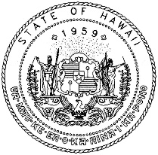
SHARON HURD
Chairperson, Board of Agriculture

DEXTER KISHIDA
Deputy to the Chairperson

State of Hawaiʻi
DEPARTMENT OF AGRICULTURE
KA ʻOIHANA MAHIʻAI
1428 South King Street
Honolulu, Hawai‘i 96814-2512
Phone: (808) 973-9600 FAX: (808) 973-9613

November 17, 2023

TO: Advisory Committee on Plant and Animals

FROM: Rodney Young
Fisheries Technician
Anuenue Fisheries Research Center (AFRC)
Division of Aquatic Resources (DAR)
Department of Land and Natural Resources (DLNR)

THROUGH: Trenton T. Yasui
Invertebrate and Aquatic Biota Specialist
Plant Quarantine Branch (PQB)
Hawaii Department of Agriculture (HDOA)

SUBJECT: Request to: (1) Allow the Importation of Peacock bass, Cichla ocellaris, a Fish on the List of Conditionally Approved Animals, by Permit, for Public Fishery Restocking, by the Hawaii Department of Land and Natural Resources; and (2) Establish Permit Conditions for the Importation of Peacock bass, Cichla ocellaris, a Fish on the List of Conditionally Approved Animals, by Permit, for Public Fishery Restocking, by the Hawaii Department of Land and Natural Resources.

- Summary Description of the Request

PQB NOTES: The Plant Quarantine Branch (PQB) submittal for requests for import or possession permits, as revised, distinguishes information provided by the applicant from procedural information presented by PQB. With the exception of PQB notes, hereafter “PQB NOTES,” the text shown below in section II from page 2 through page 14 of the submittal was taken directly from the DLNR’s application and subsequent written communications provided by the applicant, Mr. Rodney Young. For instance, the statements on page 14 regarding effects on the environment are the applicant’s statements in response to standard PQB questions and are not PQB’s statements. This approach for PQB submittals aims for greater applicant participation in presenting intrastate transfer or import requests in order to move these requests to the Board of Agriculture (Board) more quickly, while distinguishing applicant provided information from PQB information. The portion of the submittal prepared by PQB, including the summary description of the request, Environmental Assessment Issue, Advisory Subcommittee Review, and Proposed Import Permit Conditions, are identified as sections I, III, IV and V of the submittal, which start at pages 1, 14, 15, and 19 respectively.

We have a request to review the following:

COMMODITY: One shipment of (12) Peacock bass, C. ocellaris, 8-9 inches in size.

SHIPPER: Predatory Fins, 750 Montauk Highway, Copiague, New York 11726.

Predatory Fins is a retail aquatic fish and aquarium products supplier.
Founded in 2017, based in Florida. 160 NW 24th St., Bay 14, Boca Raton Florida. Currently, they have closed the Florida store and moved to 750 Montauk Hwy., Copiague, New York 11726. Owner Rodrigo Rojas employs 2 people with an annual revenue of $94,355.00.
A fish broker that imports all over the world and sells them anywhere in the USA.

IMPORTER: Rodney Young, Fisheries Technician, AFRC, DAR, DLNR, 1039 Sand Island Parkway, Honolulu, HI 96819.

Mr. Young is currently employed with the State of Hawaii, DLNR/DAR as a Fishery Technician V, and has served for 29 years with the DAR AFRC. From 2018 to present, Mr. Young has been project leader for the Rainbow trout Sport Fishing Restoration Program, and the AFRC trout fish hatchery and stocking of Puu Lua reservoir, Kokee, Kauai for the annual public Rainbow trout fishing open, and provide technical guidance for the Wahiawa Middle School fish hatchery.

CATEGORY: Peacock bass, C. ocellaris, is on the List of Conditionally Approved Animals. Pursuant to chapter 4-71, Hawaii Administrative Rules, C. ocellaris may be imported into Hawaii for individual possession, businesses, government agencies, or institutions.

II. Information Provided By the Applicant in Support of the Application

PQB NOTES: The Peacock bass, C. ocellaris, is referred to as “butterfly Peacock bass” in the applicant’s provided information.

PROJECT: The DAR manages the State’s marine and freshwater resources through programs in commercial fisheries and aquaculture; aquatic resources protection, enhancement, and education; and recreational fisheries. One of the major program areas include projects to provide facilities and opportunities for recreational fishing consistent with the interests of the State.

The Division manages the Wahiawa Public Fishing Area which has an existing population of butterfly Peacock bass and other freshwater gamefish to provide a recreational fishing opportunity for the public.

OBJECTIVE: The restocking of Peacock bass is to refresh the genetic diversity of the existing population. The imported Peacock bass will be used as brood stock for spawning to produce fingerlings for eventual stocking in the reservoir. The next generations (F1. F2…etc.) of Peacock bass will only be stocked in Wahiawa Reservoir. The timeline would be about 2 years before the release of the first generation of Peacock bass.

PROCEDURE: The imported butterfly Peacock bass will be quarantined and checked for disease at AFRC and placed in large tanks until natural pairing occurs and removed to individual tanks for spawning. Some of the mated pairs (3) of butterfly Peacock bass will be transported to Wahiawa Middle School for spawning in their large outside ponds.

DISCUSSION:

- Person Responsible: Rodney Young, Fisheries Technician, AFRC, DAR, DLNR, 1039 Sand Island Parkway, Honolulu, HI 96819.

2. Safeguard Facility and Practices: State of Hawaii, AFRC, DAR, DLNR, 1039 Sand Island Parkway, Honolulu, HI 96819, Telephone no.: (808) 832-5000, FAX: (808) 832-5012.

The AFRC is located on Sand Island and is adjacent to the U.S. Coast Guard Station. Water effluent drain from the facility empties into the marine environment directly into Honolulu Harbor. This provides a biosecurity mechanism as the butterfly Peacock bass cannot survive in saltwater. The butterfly Peacock bass will be quarantined in tanks next to the rainbow trout hatchery.

Biosecurity: The butterfly Peacock bass will be maintained at AFRC and/or the Wahiawa Middle School Hatchery for brood stock. The brood stock fish will be maintained for their reproductive lifespan to produce offspring for stocking only in the Wahiawa Reservoir and when no longer needed and/or mortality occurs specimens will destroyed by freezing and disposed of in a permitted landfill.

The following subsections describe the Wahiawa Middle School fish hatchery and AFRC property location and freshwater fish hatchery layout .

Wahiawa Middle School fish hatchery
275 Rose St, Wahiawa, HI 96786

The fish hatchery, where the butterfly Peacock bass will be maintained, is located on the Wahiawa Middle School’s property. It has a perimeter fence with one entrance located at the front of the hatchery building. Entry is limited to staff, volunteers and school faculty involved with the fish hatchery. The discharge water from the fish hatchery will go into the Honolulu City and County wastewater sewer system. Lake Wilson’s south fork water way is located, at its nearest point to the fish hatchery, 300 yards away.

Below are two maps showing the location of the Wahiawa Middle School fish hatchery and its vicinity to Wahiawa Lake Wilson Public Fishing Area.

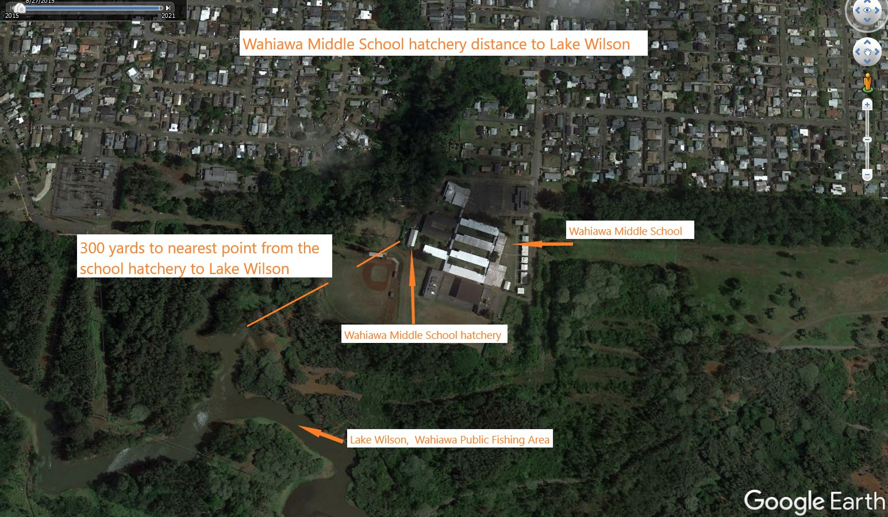
Map 1. Shown is the location of the Wahiawa Middle School fish hatchery.

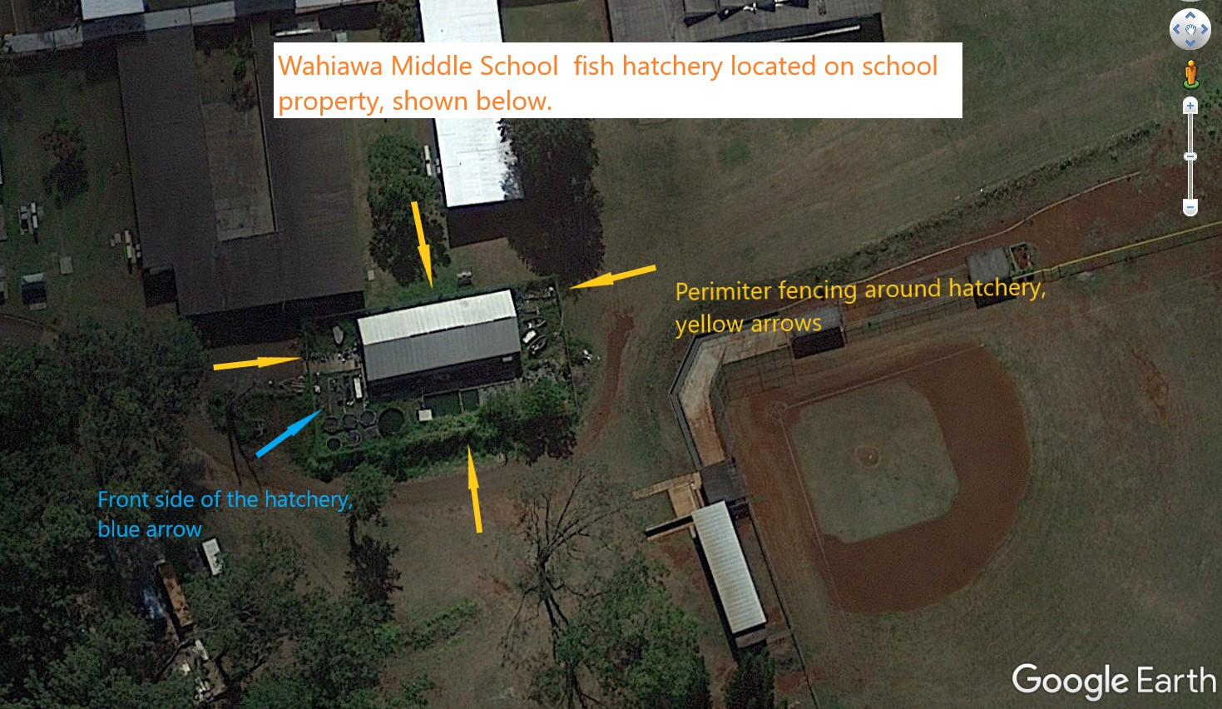
Map 2. Shows the perimeter fencing around the fish hatchery and area layout.

Below are 6 photos showing the fish hatchery within the perimeter fence and inside the fish hatchery building.

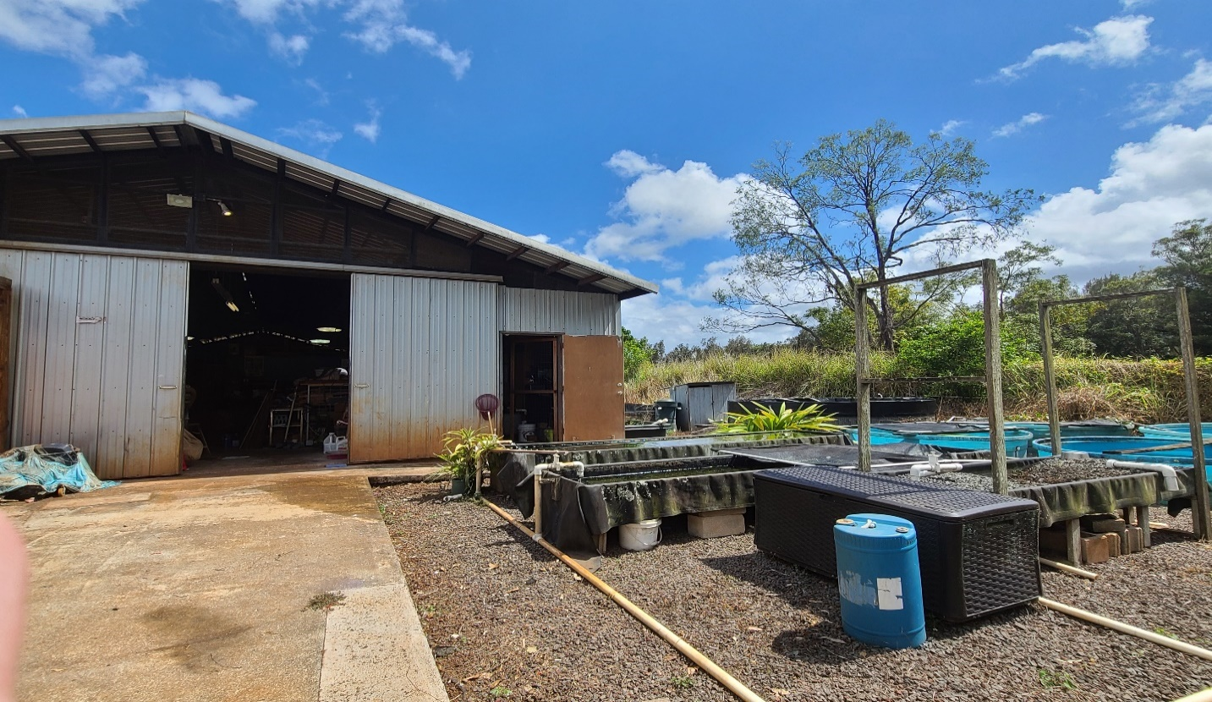
Photo 1. Front view of the hatchery

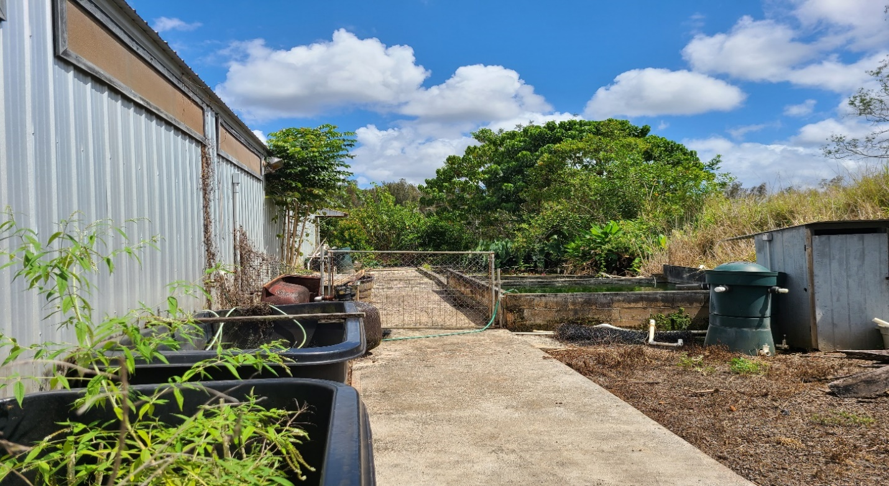
Photo 2. Right side view of the hatchery

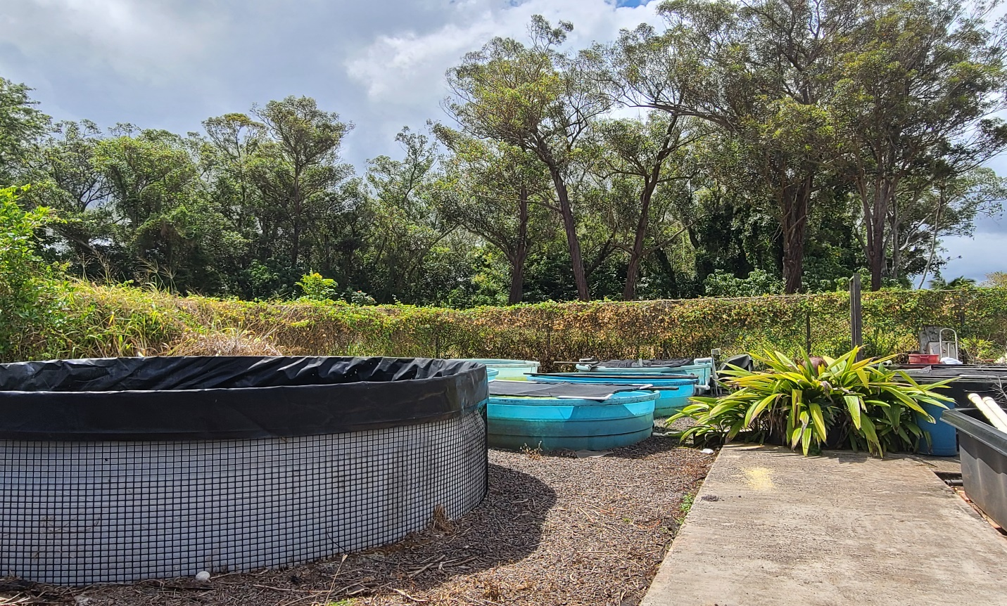
Photo 3. Back side view of the hatchery

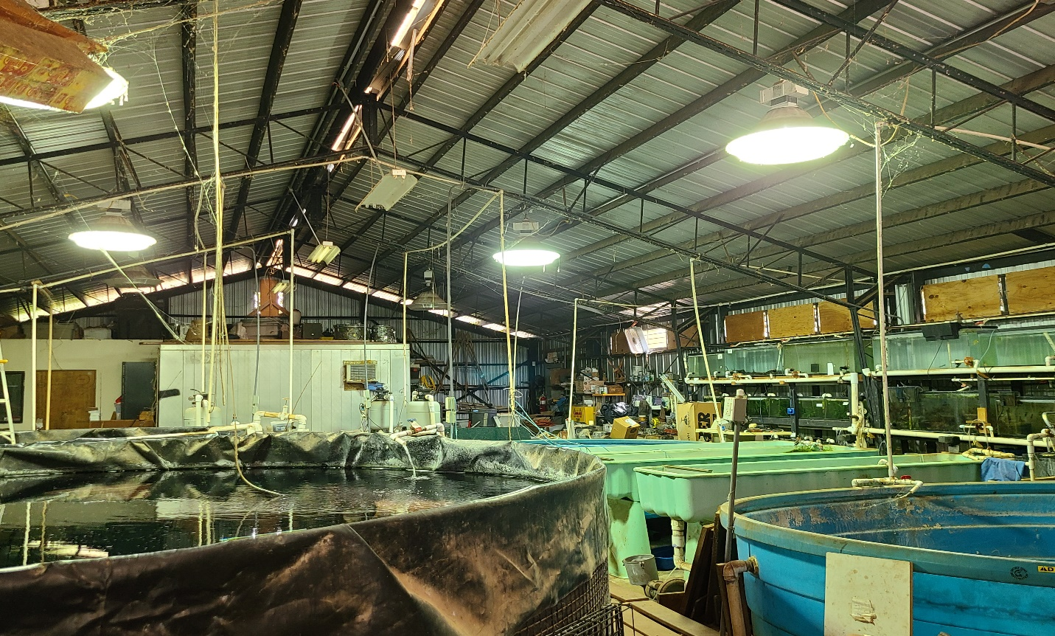
Photo 4. Inside fish hatchery, front toward the back view.

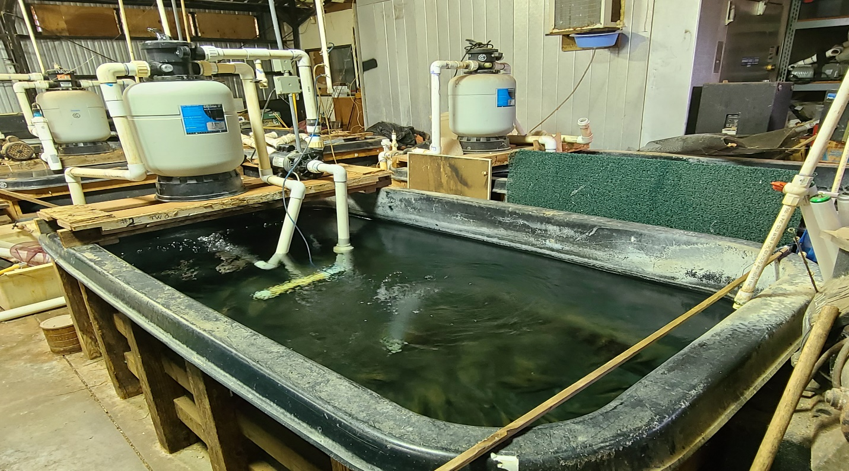
Photo 5. Rectangle tanks inside back area of the fish hatchery.

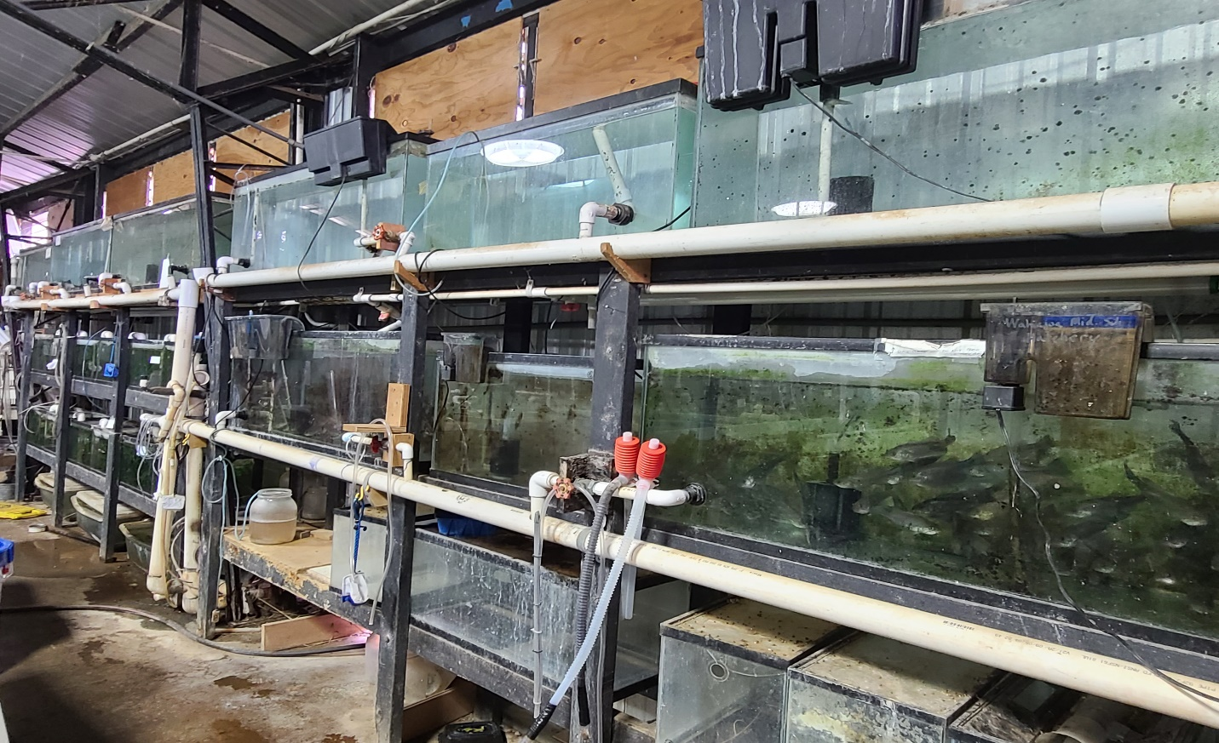
Photo 6. Aquarium tanks along the right wall inside the fish hatchery.

State of Hawaii DLNR/DAR Anuenue Fisheries Research Center
1039 Sand Island Parkway, Honolulu, Hawaii 96819

AFRC is located on Sand Island, bordered by two properties, Honolulu harbor and the public road. The bordering properties are the US Coast Guard Sector Honolulu operations port, SUBCOM fiber optic cable laying company, and Honolulu Harbor. This is shown in Map 1, below. The facility is accessed by State of Hawaii DLNR/DAR staff only. Entry onto the facility is through a secured, closed, driveway gate.

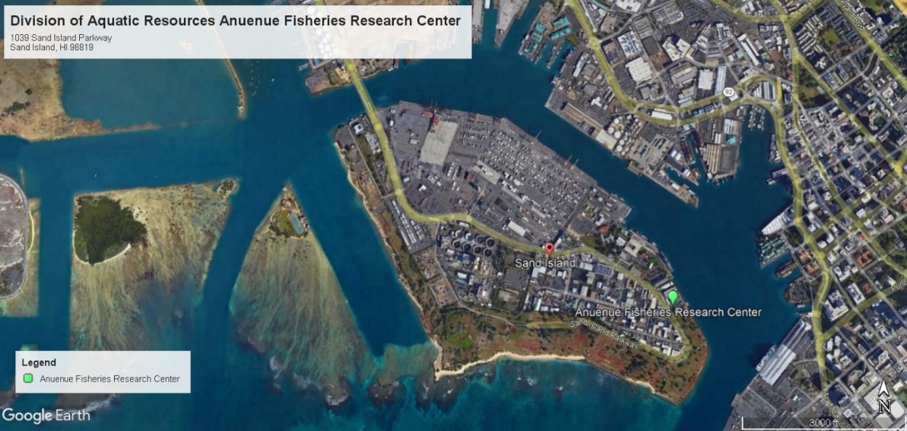
Map 1. DAR AFRC facility

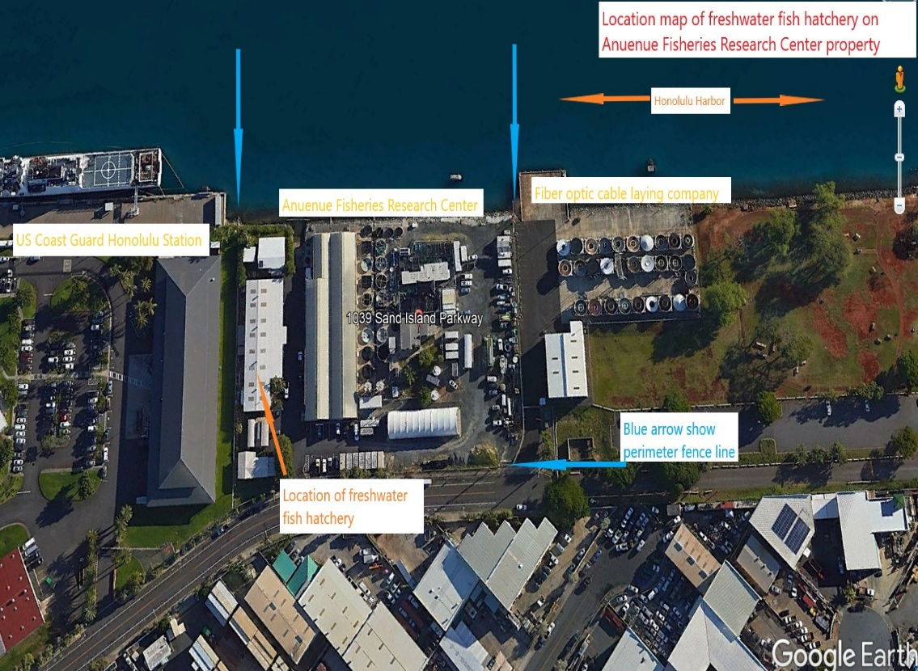
Map 2. AFRC’s freshwater fish hatchery location on Sand Island and adjacent properties.

The following 6 photos will show the internal space of the freshwater fish hatchery at AFRC.

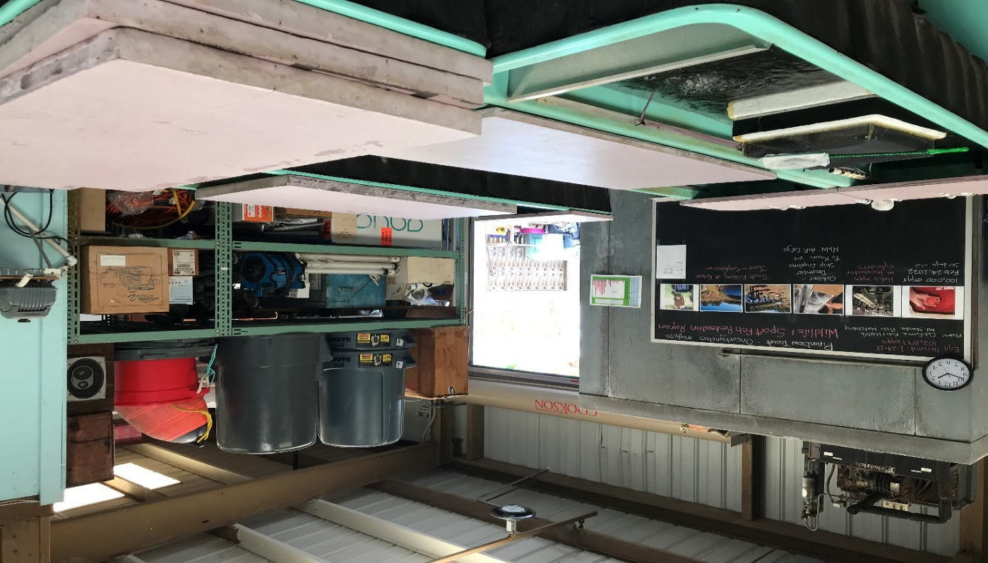
Photo 1. A view looking toward the front section and doorway to the freshwater fish hatchery.

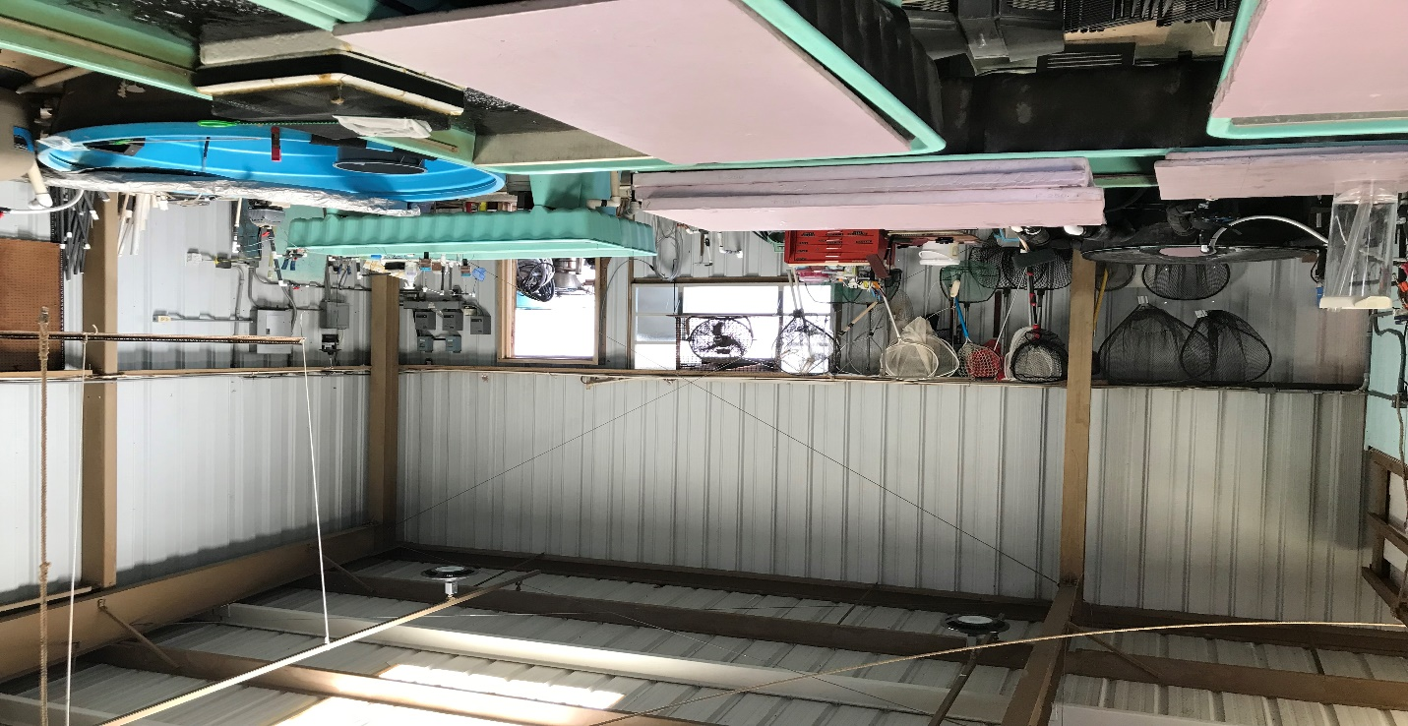
Photo 2. Looking toward the rear section of the freshwater fish hatchery with back door leading to tanks in the back section is viewed.
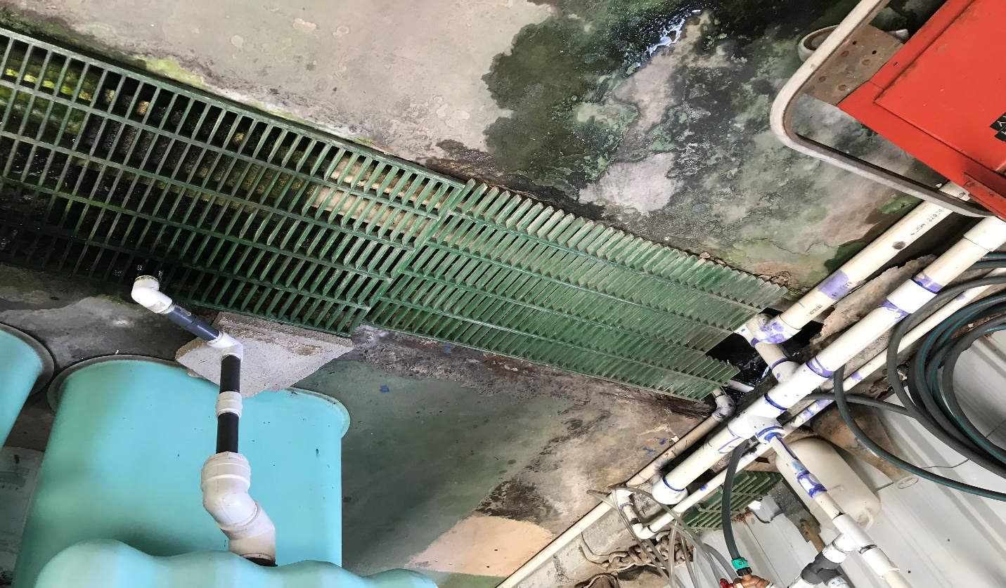
Photo 3. Shown, is a grate covering the water discharge collection trough leading toward Honolulu Harbor.

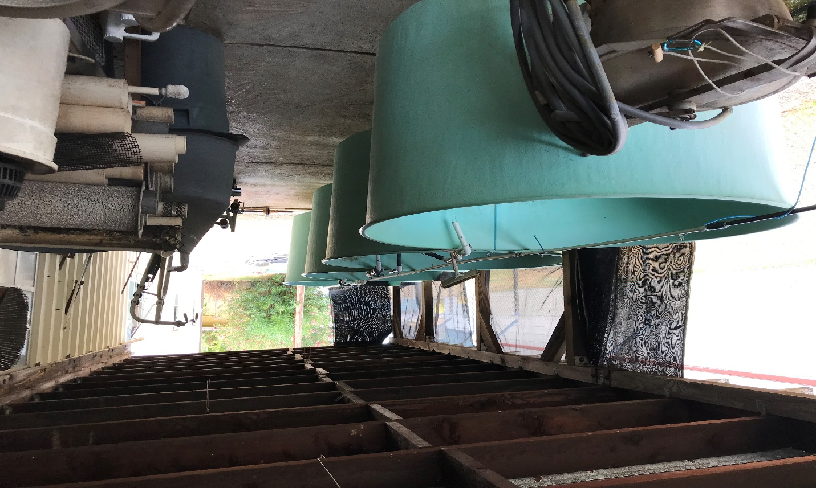
Photo 4. 4 circular tanks will be used for the imported Peacock bass.

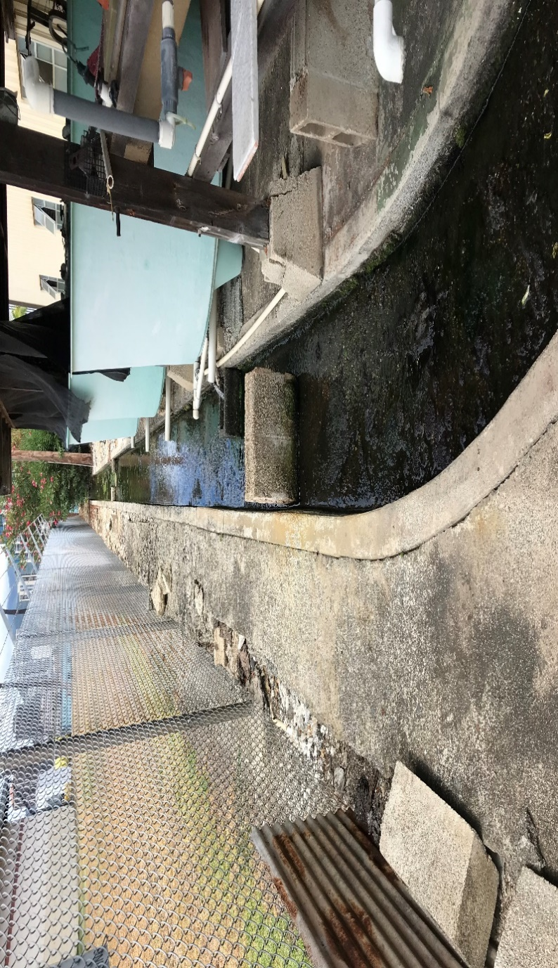
Photo 5. The same 4 circular tanks in Photo 4., here we have the property border fence line between the US Coast Guard Honolulu Sector operations facility, and the continuation of the water discharge collection trough from the internal portion of the freshwater fish hatchery.

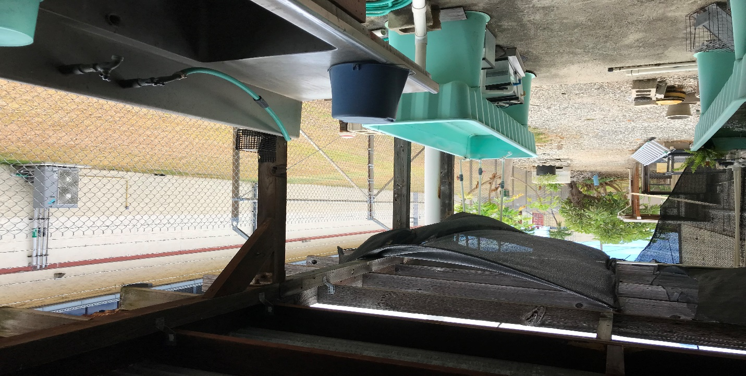
Photo 6. Shown are the long shallow tanks which may be used to hold the fingerling size Peacock bass. The direction of the view is looking toward the street, 180 degrees opposite of Honolulu Harbor and the 4 circular tanks in photo 5.
3. Method of Disposition: The butterfly Peacock bass will be maintained at AFRC and/or the Wahiawa Middle School Hatchery for brood stock. The brood stock fish will be maintained for their reproductive lifespan to produce offspring for stocking only in the Wahiawa Reservoir and when no longer needed and/or mortality occurs specimens will be destroyed by freezing and disposed of in a permitted landfill.

4. Abstract of Organism:

Classification:
Kingdom: Animalia
Phylum: Chordata
Class: Actinopterygii
Order: Cichliformes
Family: Cichlidae
Genus: Cichla
Species: Cichla ocellaris

Life History: Largest in the cichlid family and grows to about 28 inches, reaches sexual maturity at around 8 inches, and is predatory (strictly piscivorous feeding only on fish such as threadfin shad, tilapia, bluegill sunfish, and top minnows). Found in temperatures ranging from 24°-27° C (75°-81° F) , native to large freshwater bodies in Amazon basin in South America, whereas in Hawaii it is confined to reservoirs on Kauai, Oahu, Maui and Hawaii. Spawning season is May through September with spawning pairs laying eggs on hard surfaces (rocks, tree branches, etc.) and protecting them and the young newly hatched juvenile fish in the typical cichlid fashion until they gradually disperse.

Habitats: Freshwater ponds, lakes and reservoirs.

Native Range: Native range is the Amazon basin in South America. C. ocellaris was brought into the State by the Division of Fish & Game (now DAR) for recreational purposes as a gamefish and is naturalized in Hawaii in ponds and reservoirs. It was introduced in 1961 in the Wahiawa Public Fishing Area (Lake Wilson) as a gamefish.

Potential for Establishment in Hawaii: It is already established on Kauai, Oahu, Maui, and Hawaii in public and private fishing areas. Negative impact to native species in Hawaii has not been documented. However, the history of invasiveness elsewhere is high.

Establishment of Viable Populations and Invasiveness: Not considered invasive as the established viable populations inhabit reservoirs and impoundments and cannot spread through streams.

Host Range: Found on all islands-Kauai, Oahu, Maui and Hawaii. A predator strictly piscivore in nature feeding only on fish.
Domestication and Cultivation: Cultured in fishponds in South America and is highly regarded as a gamefish.

Impacts: Caught in the wild as food fish and raised in aquaculture ponds for same purpose. Also sold in aquarium trade as juveniles, but not recommended because it attains a large size.

Diseases and Pests: Eustrongylides Disease and Goexia Disease. (https://www.fishbase.se/Diseases/DiseasesList.php?ID=457&StockCode=471). Likely to harbor any protozoans, worms, and other parasites/disease that cichlids can.

5. Effects on the Environment:

C. ocellaris has already been established in Hawaii for over 31 years and hasn’t been associated with any diseases and/or pests. It was imported to Hawaii as a freshwater gamefish and has boosted economic and recreational opportunities by providing a fishery where tourists and residents can catch both largemouth and Peacock bass.

C. ocellaris doesn’t impact native freshwater stream biota as its range of habitats includes reservoirs, lakes, and impoundments. This is demonstrated by its geographical distribution in Hawaii.

6. Alternatives:

Obtain and spawn brood stock from Wahiawa Reservoir or import from established populations on neighbor islands.

7. References:

Baensch, H.A. & R. Riehl. 1993. Aquarium Atlas 2. Publishers of Natural History and Pet Books, Melle, Germany. 856-857.

Goldstein, R.J. 1973. Cichlids of the World. THF Publications, Inc. Ltd. Hong Kong. 107-110.

Devick, W.S. 1991. Job Progress Report: Disturbances and Fluctuations in the Wahiawa Reservoir Ecosystem. SFR F-14-R-15. 1-20.

Yamamoto, M.N. & A.W. Tagawa. 2000. Hawaii’s Native & Exotic Freshwater Animals. Mutual Publishing, Honolulu, HI. 1-200.

- Environmental Assessment (EA) Issue

Pursuant to a May 2008 Hawaii Intermediate Court of Appeals decision (Ohana Pale Ke Ao v. Board of Agriculture, 118 Haw. 247 (Haw. App. 2008), the Department of Agriculture’s (Department’s) import permit process is subject to the requirements of the Hawaii Environmental Protection Act (EPA), chapter 343, Hawaii Revised Statutes. Under this decision, the requirement for an EA as a condition of the import permit or related authorization applies in those circumstances where the underlying permit activity for the importation initiates a “program or project” and where the use of state or county funds or state or county lands is involved. The proposed sites for this request (DLNR AFRC, Wahiawa Middle School and Wahiawa Reservoir) are state lands therefore this project triggers an Environmental Assessment (EA).

PQB NOTES: To comply with EA requirements as mandated in HRS §343-5, the applicant has stated that the feasibility of an EA exemption will be researched.

IV. Advisory Subcommittee Review

This request was submitted to the Advisory Subcommittee on Invertebrate and Aquatic Biota for their review and recommendations. Their recommendations and comments are as follows:

- I recommend approval ___ / ___ disapproval to allow the importation of Peacock bass, Cichla ocellaris, a Fish on the List of Conditionally Approved Animals, by permit, for public fishery restocking, by the Hawaii Department of Land and Natural Resources.

Dr. Micah Brodsky, Animal Disease Control Branch, HDOA: Recommends conditional approval.

Comments: “Recommendation of approval for this permit to import Peacock bass, Cichla ocellaris is strictly conditional on the permittee meeting the following conditions and those outlined in section 2, below:

1. Perform genetic analysis of the established Peacock bass populations within Hawaii to 1) definitively establish the species / subspecies present in Hawaii (before importing new genetic stock) and 2) determine if the populations on different islands within the state have enough genetic diversity to accomplish the project goals without the need to import broodstock from out of state (thereby eliminating the risk of introducing infectious diseases from Florida or Central / South America).”

Ms. Kimberly Fuller, DAR, DLNR: Self recused.

Dr. Kauaoa Fraiola, U. S. Fish and Wildlife Service (USFWS): No response.

Dr. Andrew Rossiter, Waikiki Aquarium: Recommends approval.

Comments: “No reservations concerning importation. Biosecurity measures are exemplary.”

Mr. LeRoy Thom, Petland, Inc.: Recommends approval.

Comments: “I recommend approval to issue permit for Peacock bass, Cichla ocellaris (Tucunare) currently on the list of Conditionally Approved Animals. Furthermore, I would also suggest, in addition to the release into Wahiawa (Lake Wilson) that some of the adults or sub-adults be captured from the land locked lake and bred with your captive populations to improve both gene pools. This fish has been here for approximately thirty years and if any environmental or ecological problems came about they would have certainly surfaced by now.”

- I recommend approval ___ / ___ disapproval to establish permit conditions for the importation of Peacock bass, Cichla ocellaris, a Fish on the List of Conditionally Approved Animals, by permit, for public fishery restocking, by the Hawaii Department of Land and Natural Resources.

Dr. Micah Brodsky: Recommends conditional approval.

Comments: “The following conditions need to be met prior to permitting the importation of Peacock bass, Cichla ocellaris, in order to mitigate risks to Hawaii’s native and/or endemic species and ecosystems (and the fisheries and aquaculture industries) while enhancing stocks of a non-native game species:

- DLNR establishes, maintains, and makes available upon request, a written Biosecurity Plan that address the specific origin of the imported finfish broodstock (i.e. wild caught or captive-bred, geographic location where collected or held, etc.), pre- and post- importation quarantine, infectious disease testing, empiric parasite treatment, facilities cleaning and disinfection SOP’s, and any other measures that will be taken to prevent the introduction of infectious disease into the Wahiawa Reservoir and beyond.

- The proposed Method of Disposition (euthanasia) must be updated to a method that is accepted under the AVMA guidelines on euthanasia. [Note: Freezing of unanesthetized finfish is specifically listed under “Unacceptable Methods ”in section 6.2.4 of the 2020 AVMA Guidelines on Euthanasia]

- Relevant recent references, including a 2018 USFWS Butterfly Peacock bass Ecological Risk Screening Summary, should be reviewed and included in a revised application.
- For example, section 4 of the application(“Abstract of Organism”), sub-heading “Establishment of Viable Populations and Invasiveness” erroneously states that the species is “Not considered invasive as the established viable populations inhabit reservoirs and impoundments and cannot spread through streams.” The spread of Peacock bass through stream, river, and canal systems is well documented, with published reports dating back to 1973.

- A site visit and review of the security and biosecurity infrastructure in place at Wahiawa High School (WHS) shall be required prior to authorization to utilize the facility site for housing and breeding a highly invasive, non-native fish species.

- Specific education and outreach goals, including biosecurity and invasive species management considerations, should be established and paired with this activity, so that students and community members can gain an understanding of the careful planning and precautions that were taken to safeguard Hawaii’s native species and ecosystems while enhancing stocks of a non-native game species.”

- If specimens are sourced from within the state of Hawaii:

Pre shipment quarantine: 30 days

Dip treatments for external parasites: Formalin (2 times at 14-21 day interval), Potassium Permanganate (2 times at 14-21 day interval)

Post shipment quarantine: 30 days

Dip treatments for external parasites: Formalin (1 time), Potassium Permanganate (1 time)

Conditions for release from quarantine: Site visit, visual examination, skin scrape and gill clip performed by a qualified aquatic animal disease specialist on 10% of the population (minimum 5 fish) by an HDOA Veterinary Medical Officer.

- If specimens are sourced from outside of the state of Hawaii:

Pre shipment quarantine: 45 days

Dip treatments for external parasites: Formalin (2 times at 14-21 day interval), Potassium Permanganate (2 times at 14-21 day interval)
Pre-shipment Infectious Disease testing: Prior to shipping (samples collected not more than 21 days before specimens’ arrival in Hawaii), tests for the following diseases shall be conducted by PCR methods, at an accredited laboratory:
- Infectious pancreatic necrosis virus (IPNV, Aquabirnavirus)
- Nervous necrosis virus (VNN, Betanodavirus)
- Tilapia larvae encephalitis virus (TLEV, Herpesvirus)
- Bohle iridovirus (BIV, Ranavirus)
- Infectious spleen and kidney necrosis virus (ISKNV, Megalocytivirus)
- Lymphocystis disease virus (LCDV, Iridoviridae)
- EUS/Aphanomyces invadans
- Aeromonas salominicidica

Post shipment quarantine: 30 days

Dip treatments for external parasites: Formalin (1 time), Potassium Permanganate (1 time)

Conditions for release from quarantine:

- Site visit, visual examination, skin scrape and gill clip performed by a qualified aquatic animal disease specialist on 10% of the population (minimum 5 fish) by an HDOA Veterinary Medical Officer.

- Tests for the following diseases shall be conducted by PCR methods (samples collected not more than 10 days before specimens are to be released from quarantine), at the same accredited laboratory where they were performed for the pre-shipping:

- Infectious pancreatic necrosis virus (IPNV, Aquabirnavirus)
- Nervous necrosis virus (VNN, Betanodavirus)
- Tilapia larvae encephalitis virus (TLEV, Herpesvirus)
- Bohle iridovirus (BIV, Ranavirus)
- Infectious spleen and kidney necrosis virus (ISKNV, Megalocytivirus)
- Lymphocystis disease virus (LCDV, Iridoviridae)
- EUS/Aphanomyces invadans
- Aeromonas salominicidica”

Ms. Kimberly Fuller: Self recused.

Dr. Kauaoa Fraiola: No response.

Dr. Andrew Rossiter: Recommends approval.

Mr. LeRoy Thom: Recommends approval.
Comments: “Established permit conditions are adequately addressed as is and need no unnecessary revisions.”

V. Proposed Import Permit Conditions

PQB Notes: Proposed permit conditions no. 5-6 and 11-12 were inserted in response to Subcommittee member Brodsky’s comments and recommendations, and subsequent to the review by the Advisory Subcommittee on Invertebrate and Aquatic Biota.

- The restricted article(s), Peacock bass, Cichla ocellaris, shall be imported, reared, and released for public fishing, a purpose approved by the Board of Agriculture (Board).

- The permittee, Rodney Young, Anuenue Fisheries Research Center (AFRC), Division of Aquatic Resources, 1039 Sand Island Parkway, Honolulu, HI 96819, shall be responsible and accountable for the restricted article(s) and progeny thereof, imported from the time of arrival until final disposition.

- The restricted article(s) shall be safeguarded at: 1) Hawaii Department of Land and Natural Resources Anuenue Fisheries Research Center (AFRC), 1039 Sand Island Parkway, Honolulu, HI 96819; and 2) Wahiawa Middle School, 275 Rose St, Wahiawa, HI 96786, sites inspected and approved by the Plant Quarantine Branch (PQB).

- The restricted article(s) shall be maintained by the responsible person, Rodney Young, Anuenue Fisheries Research Center (AFRC), Division of Aquatic Resources, 1039 Sand Island Parkway, Honolulu, HI 96819, or by trained or certified personnel designated by the permittee.

- Each shipment of the restricted article(s) shall be quarantined for 45 days prior to shipment, and dip-treated for parasites as follows:

- Formalin: 2 times at 14 - 21-day intervals

- Potassium Permanganate: 2 times at 14 – 21-day intervals

- Each shipment of the restricted article(s) shall be tested by Polymerase Chain Reaction (PCR) at an accredited laboratory for each of the diseases listed below. Test samples shall be collected less than 21 days prior to arrival of each shipment of restricted article(s) into the state.

- Infectious pancreatic necrosis virus (IPNV, Aquabirnavirus)

- Nervous necrosis virus (VNN, Betanodavirus)

- Tilapia larvae encephalitis virus (TLEV, Herpesvirus)
- Bohle iridovirus (BIV, Ranavirus)

- Infectious spleen and kidney necrosis virus (ISKNV, Megalocytivirus)

- Lymphocystis disease virus (LCDV, Iridoviridae)

- Epizootic ulcerative syndrome (EUS)/Aphanomyces invadans

- Aeromonas salominicidica

- Each shipment of the restricted article(s) shall be accompanied by a complete copy of the PQB permit for the restricted article(s) and an invoice, packing list or other similar PQB approved document listing the scientific and common names of the restricted article(s), the quantity of the restricted article(s), the shipper, and the permittee for the restricted article(s).

- The restricted article(s) shall be imported only through the port of Honolulu, as approved by the Board. Entry into the State through another port is prohibited unless designated by the Board.

- At least four sides of each parcel containing the restricted article(s) shall be clearly labeled in plain view with “Live Animals” and “This Parcel May be Opened and Delayed for Agriculture Inspection”, in 1/2” minimum sized font.

- Water used to transport the restricted article(s) shall be disinfected with a solution of 50 mg chlorine/L (50 ppm), for a duration of 30 minutes, then neutralized with sodium thiosulfate, another approved neutralizing agent, or by aerating and holding the solution for 48 hours prior to disposal into an individual wastewater system, municipal sewer system or other PQB approved system.

- The permittee shall quarantine the restricted article(s) for 30 days after arrival at the permittee’s approved site(s) and shall dip-treat the restricted article(s) for parasites with Formalin and Potassium Permanganate.

- The restricted article(s) shall be released from post-entry quarantine by a Hawaii Department of Agriculture (HDOA) Veterinary Medical Officer after the following conditions are met:

- A site visit, visual examination, skin scrape and gill clip shall be performed by an HDOA Animal Disease Control Branch approved aquatic animal disease specialist on 10% of the population (minimum 5 fish).

- PCR tests for the following diseases shall be conducted at the same accredited laboratory that performed the pre-entry disease testing (test samples shall be collected less than 10 days prior to projected release from quarantine):

- Infectious pancreatic necrosis virus (IPNV, Aquabirnavirus)
- Nervous necrosis virus (VNN, Betanodavirus)
- Tilapia larvae encephalitis virus (TLEV, Herpesvirus)
- Bohle iridovirus (BIV, Ranavirus)
- Infectious spleen and kidney necrosis virus (ISKNV, Megalocytivirus)
- Lymphocystis disease virus (LCDV, Iridoviridae)
- EUS/Aphanomyces invadans
- Aeromonas salominicidica

- Effluent from the permittee’s system shall be sufficiently screened and treated, as determined by the PQB chief, to prevent the accidental release of the restricted article(s) and progeny thereof, and/or any associated diseases or parasites. Un-screened and/or untreated effluent shall not be discharged to or have a direct connection to the ocean or any other body of water, such as ponds, estuaries, reservoirs, rivers and/or streams.

- The permittee shall adhere to the use, facility, equipment, procedures, and safeguards described in the permit application, and as required by the Board and the PQB chief.

PQB NOTES: The underlined section in proposed permit condition no. 15 below is language recommended by Advisory Committee member Brodsky.

- The permittee shall have a biosecurity manual available for review and approval by the PQB, at the time of the initial site inspection and any subsequent post-entry inspection(s), which identifies the practices and procedures to be adhered to by the permittee and any authorized individuals, to minimize or eliminate the risk of theft, escape, or accidental release of the restricted article(s) and progeny thereof, including the risk of introduction and spread of diseases and pests associated with the restricted article(s) and progeny thereof, to the environment, *including but limited to: pre- and post- importation quarantine, infectious disease testing, empiric parasite treatment, facilities cleaning and disinfection SOP’s, and any other measures that will be taken to prevent the introduction of infectious disease into the approved release site. The biosecurity plan shall include the specific origin of the restricted article(s) (i.e. wild caught or captive-bred, geographic location where collected or held, etc.). The permittee and the permittee’s employees shall adhere to all practices and procedures stated in the biosecurity procedure at all times.

- The approved site, restricted article(s), and progeny thereof, and records pertaining to the restricted article(s) may be subject to post-entry inspections by the PQB and/or the Animal Industry Division, HDOA, upon arrival of the restricted article(s) at the permittee’s facility. The permittee shall make the site, restricted article(s) and records pertaining to the restricted article(s) and progeny available for inspection upon request by a PQB inspector.

- The permittee shall immediately notify the PQB chief verbally and in writing under the following circumstances:

- If a shipment of the restricted article(s) is delivered to the permittee without a PQB “Passed” stamp, tag or label affixed to the article, container or delivery order that indicates that the shipment has passed inspection and is allowed entry into the State. Under this circumstance, the permittee shall not open or tamper with the shipment and shall secure, as evidence, all restricted article(s), shipping container(s), shipping document(s) and packing material(s) for PQB inspection.

- If any escape, theft, unauthorized release, disease outbreaks, pest emergence and/or mass mortalities involving the restricted article(s), including progeny, under this permit occurs. The department may confiscate or capture the restricted article(s) and any progeny that escapes or is found to be free from confinement due to unauthorized release, at the expense of the owner, pursuant to the HRS §150A-7(c).

- Prior to any changes made to the approved sites, facilities, or containers used to hold the restricted article(s), including progeny.

- If the permittee is found in violation of any municipal, state and/or federal policies, rules and/or laws, pertaining to the restricted article(s).

- If the permittee will no longer import and/or possess the restricted article(s). Under this circumstance, the permittee shall inform the PQB chief of the final disposition of the restricted article(s), including progeny, and the permit will be cancelled.

- The HDOA Veterinary Medical Officer shall be immediately notified of any mass mortalities, and signs and/or occurrence of disease in the restricted article(s) and/or progeny thereof.

- The permittee shall submit to the PQB chief a copy of all valid licenses, permits, certificates or other similar documents required by other agencies for the restricted article(s). The permittee shall immediately notify the PQB chief in writing when any of the required documents are suspended, revoked, or terminated. This permit may be amended, suspended, or cancelled by the PQB chief in writing, upon suspension, revocation, or termination of any required license, permit, certificate, or similar document for the restricted article(s).

- It is the responsibility of the permittee to comply with all applicable requirements of municipal, state, or federal law pertaining to the restricted article(s).

- The permittee is responsible for all costs, charges, or expenses incident to the inspection, treatment, or destruction of the restricted article(s) under this permit as provided in Act 173, Session Laws of Hawaii 2010, section 13, including, if applicable, charges for overtime wages, fixed charges for personnel services, and meals.

- Any violation of the permit conditions may result in citation, cancellation of the permit, and enforcement of any or all of the penalties set forth in HRS §150A-14, and any other laws of the State of Hawaii.

- A cancelled permit is invalid and upon written notification from the PQB chief, all restricted article(s) listed on the permit shall not be imported. In the event of permit cancellation, any restricted article(s) imported under permit, and progeny thereof, may be moved, seized, treated, quarantined, destroyed, or shipped out of State at the discretion of the PQB chief. Any expense or loss in connection therewith shall be borne by the permittee.

- The permit conditions are subject to cancellation or amendment at any time due to changes in statute or administrative rules restricting or disallowing import of the restricted article(s) or due to Board action disallowing a previously permitted use of the restricted article(s).

- These permit conditions are subject to amendment by the PQB chief in the following circumstances:

  - To require disease screening, quarantine measures, and/or to place restrictions on the intrastate movement of the restricted article(s) and progeny thereof, as appropriate, based on validated risks associated with the restricted article(s) as determined by the PQB chief, to prevent the introduction or spread of disease(s) and/or pests associated with the restricted article(s).

  - To conform to more recent Board approved permit conditions for the restricted article(s) as necessary to address validated risks associated with the restricted article(s).

27. The permittee shall agree in advance to defend and indemnify the State of Hawaii, its officers, agents, employees, and Board of Agriculture members for any and all claims against the State of Hawaii, its officers, agents, employees, or Board of Agriculture members that may arise from or be attributable to any of the restricted article(s) that are introduced under this permit. This permit condition shall not apply to a permittee that is a federal or State of Hawaii entity or employee, provided that the State or federal employee is a permittee in the employee’s official capacity.

ADVISORY COMMITTEE REVIEW: May we request your recommendation and comments at the next meeting of the Advisory Committee on Plants and Animals.

